**Lab Acivity 5 k.bhanuteja**  **DAY-5**

**1.** **Develop a system using UML for Personal Loan Management System. The admin should add new customers and view the customer's records. The admin should check the defaulters. The customer can see his/her account detail and apply for a new loan by providing the required documents, and Page 5 of 6 payslip. The admin should verify the document submitted and approve the loan after verifying the payback potential of the customer.**

**AIM:-**

To develop a system using UML for Personal Loan Management System.

UML DESIGNS:-

1.USE CASE:

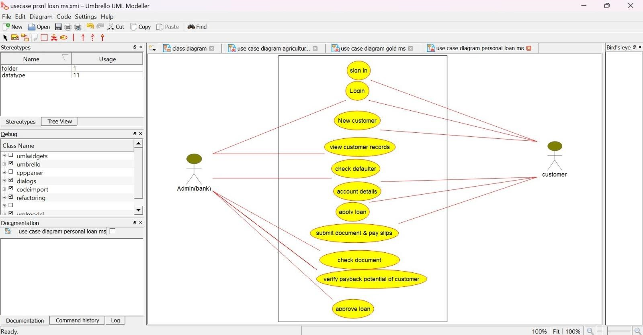

2.CLASS DIAGRAM:

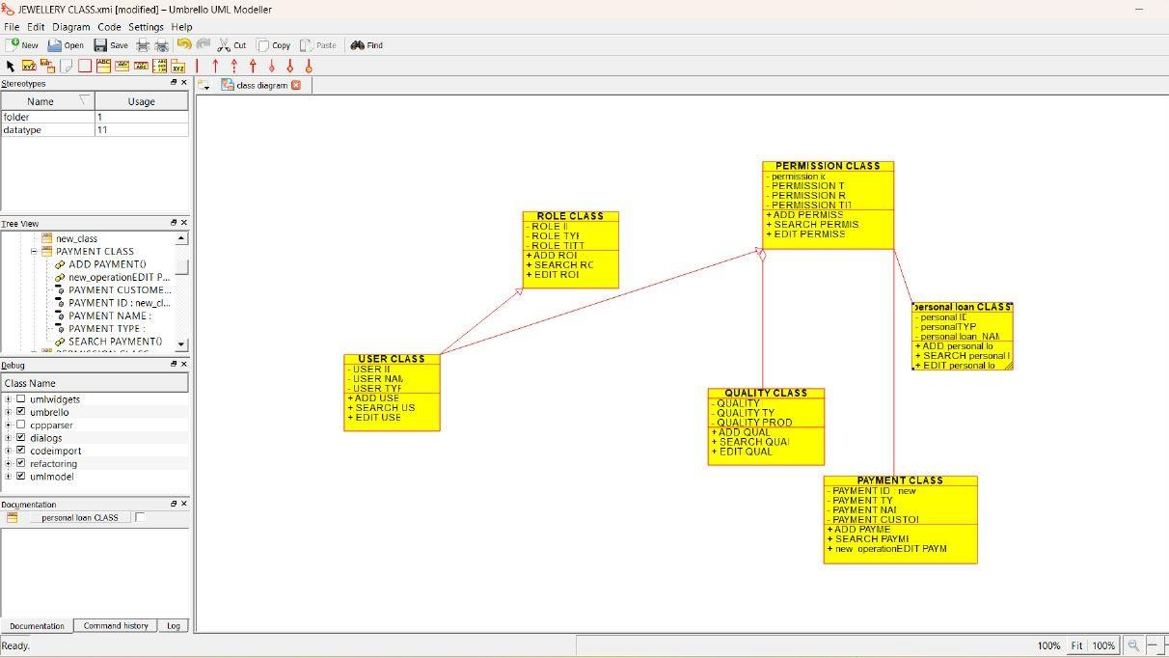

3.SEQUENCE DIAGRAM:

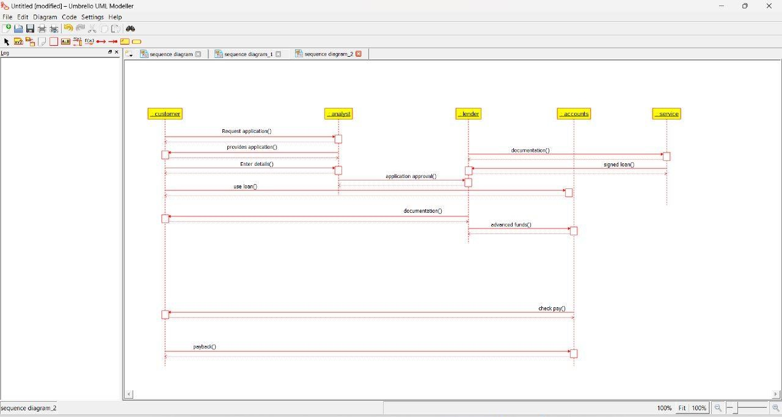

**2.** **Develop a system using UML for Car/Bike Vehicle Booking System. The system should support the renting of different automobiles by the customer. Each vehicle should have a unique access detail. The system should be able to send a notification whenever the reservation is approaching the pick-up date, as well as when the vehicle is nearing the due date. The system should maintain a vehicle log to track all events related to the vehicles.**

**AIM:-**

To develop a system using UML for Car/Bike Vehicle Booking System.

UML DESIGNS:-

1.USECASE:

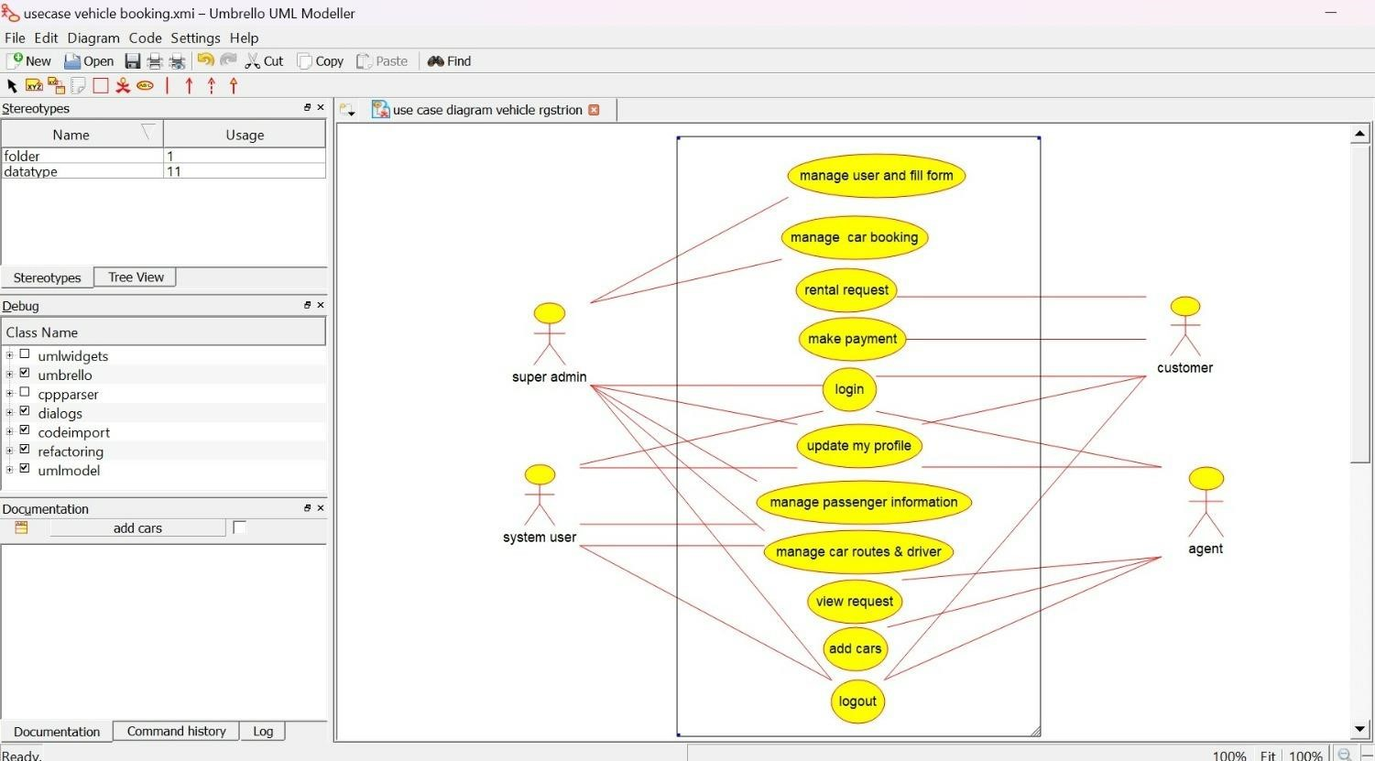

2. SEQUENCE DIAGRAM:

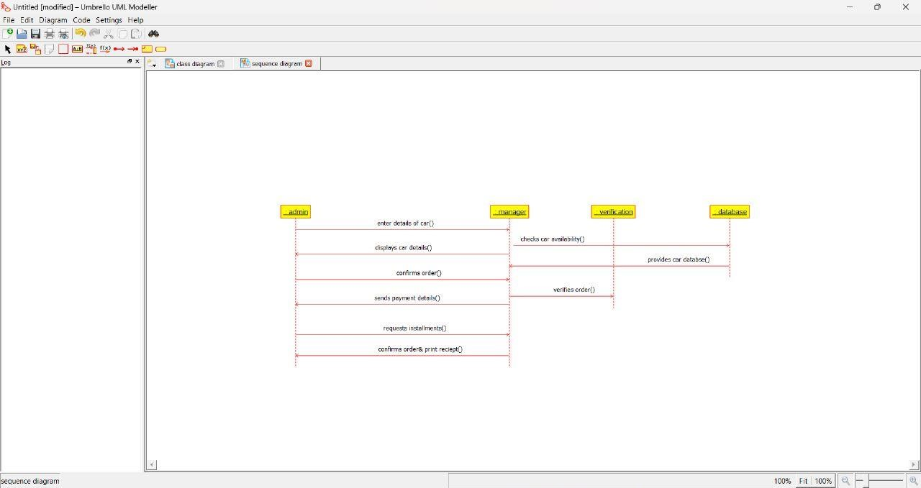

3.CLASS DIAGRAM:

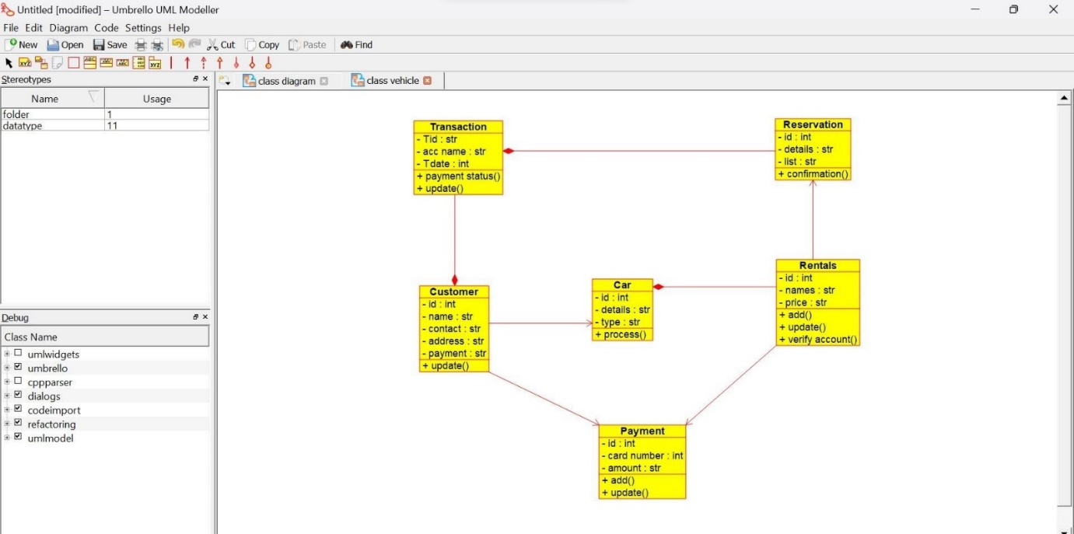

**3. Develop a system using UML for Doctor Appointment System. The central system should manage doctors’ availability and appointments for the given date. The patient can book the doctor’s appointment based on the doctor’s availability. When the booking is confirmed, it should be updated with the patient and doctor.**

**AIM:-**

To develop a system using UML for Doctor Appointment System.

UML DESIGNS:-

1. ACTIVITY DIAGRAM:

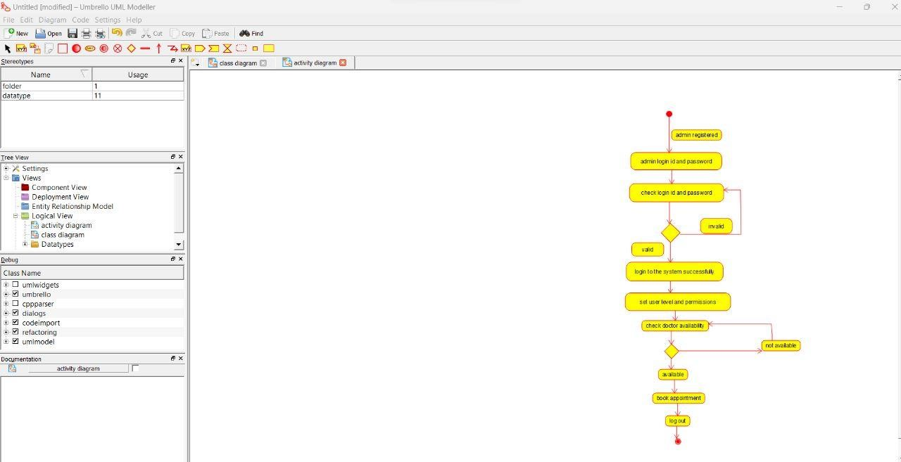

2.CLASS:

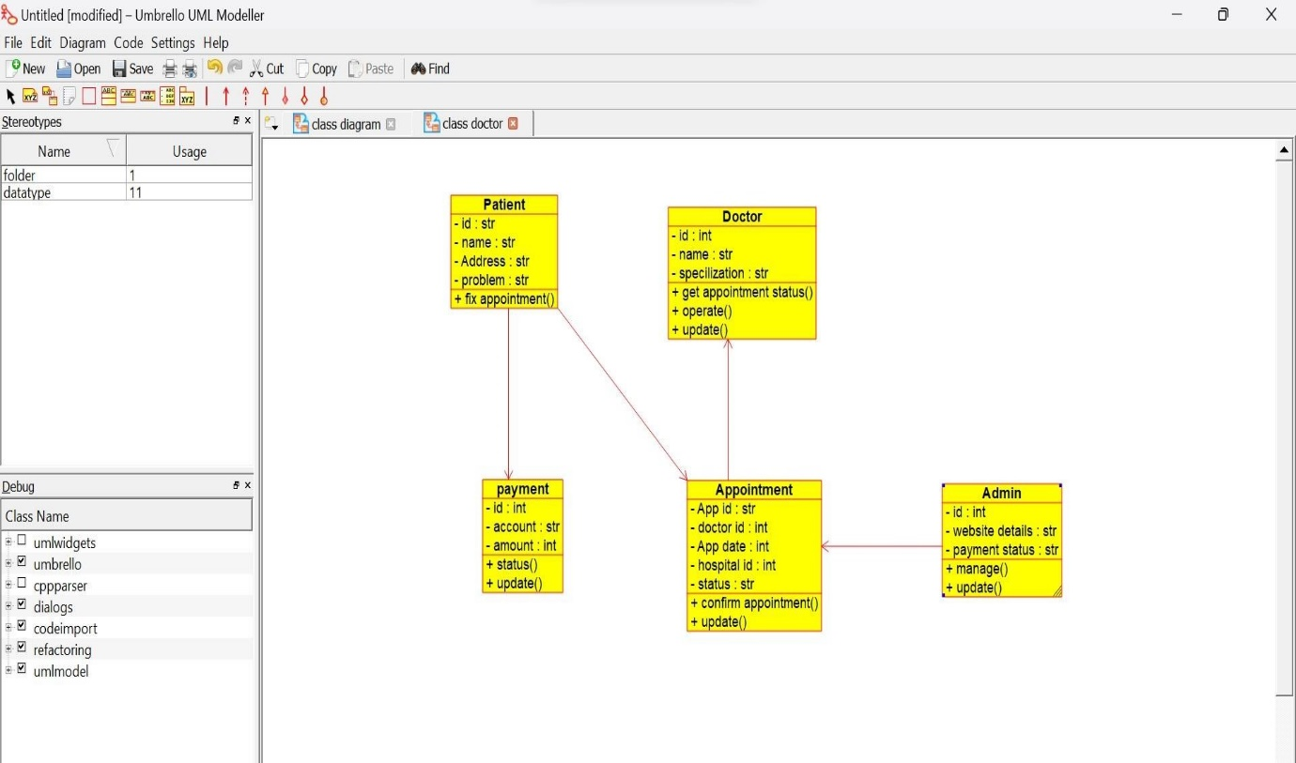

3.USECASE DIAGRAM:

